**13X SOP REFERENCE:** [SUN77_SOP_RTA-CM_Brand Hierarchy Creation_v4.0](../../../../../01%20ADMIN/102%20-%20STANDARD%20OPERATING%20PROCEDURE/02%20ENOVIA/01%20BRAND%20HIERARCHY/SUN77_SOP_RTA-CM_Brand%20Hierarchy%20Creation_v4.0.doc)

**BRAND HIERARCHY CREATION**

1. 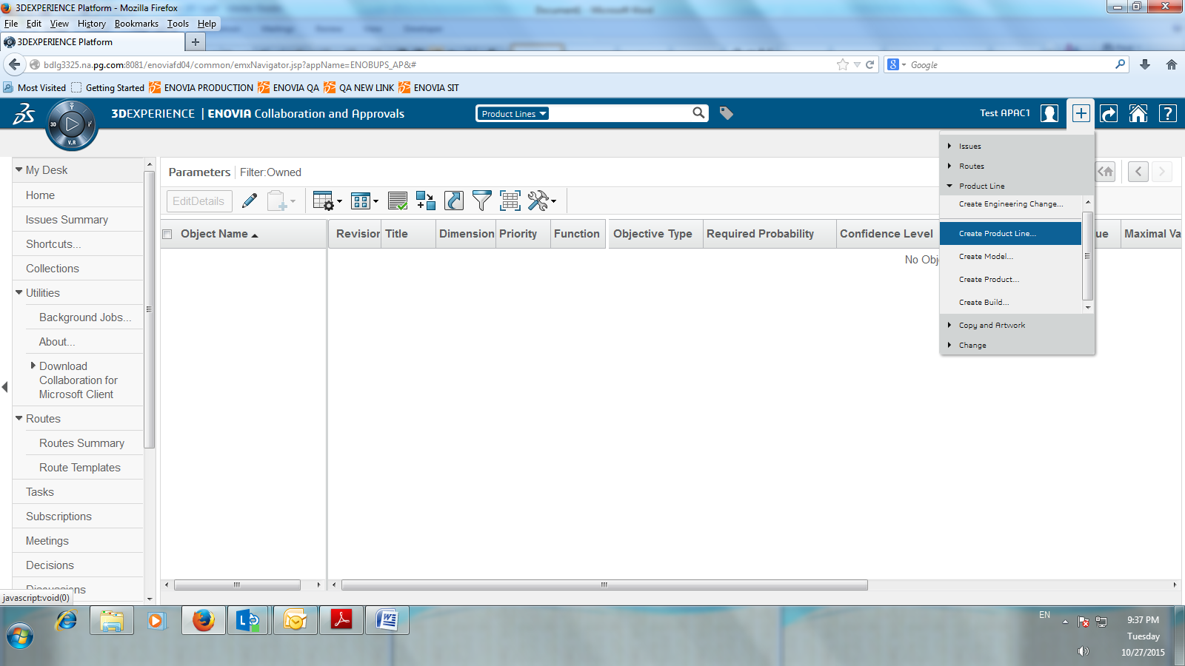Click the icon at the upper right side of the window and select “**Create Product Line**”. (*To create Brand level*)
2. Create New Product Line window will appear, mark the checkbox on “Auto name” for the system to automatically create the unique name of the Level you are going to create then enter the **Type**, **Marketing Name**, **Marketing Text** and **Description** then click “**Done**” button to save.

**Note:**

* **> 100** characters in Marketing Name is now accepted by the system
* 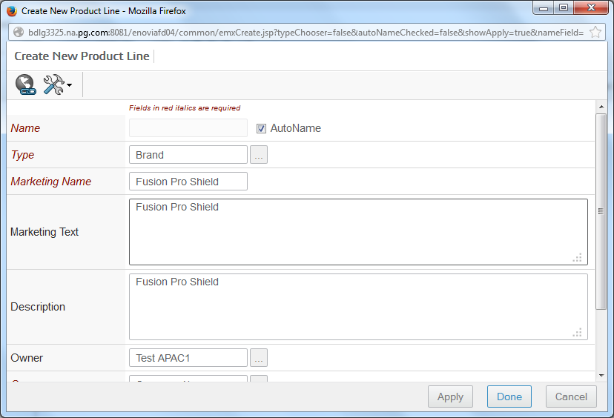Brand & Sub-Brand level is now a free-type field compared to the previous version which is in a Picklist Type field.

1. A message prompt will appear, click “**Ok**”.

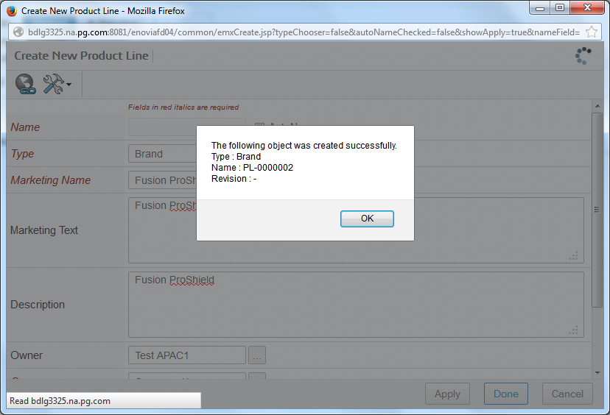

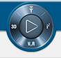**Note:** Other way to create a Brand Level in Enovia 15x.

1. Click the compass button “**My Social and Collaborative Apps**” then click “**Copy & Artwork Management**”

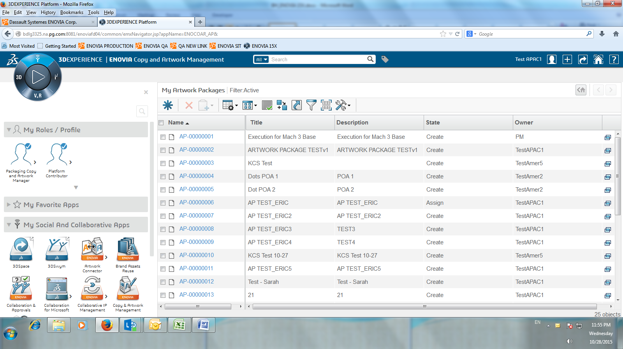

1. Click **Product Lines** under Product Line and click **Create button**

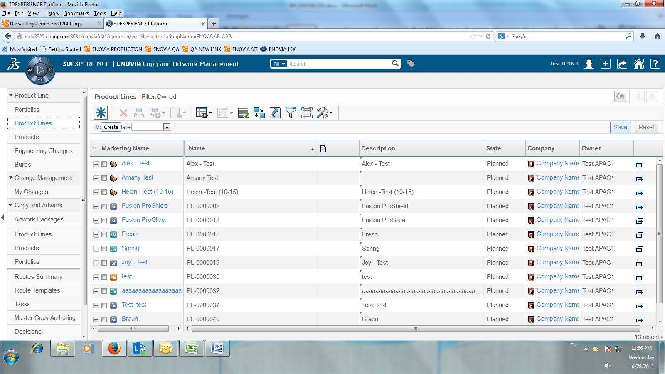

1. Mark the checkbox on “Auto name” for the system to automatically create the unique name of the Level you are going to create then enter the **Type**, **Marketing Name**, **Marketing Text** and **Description** then click “**Done**” button to save.

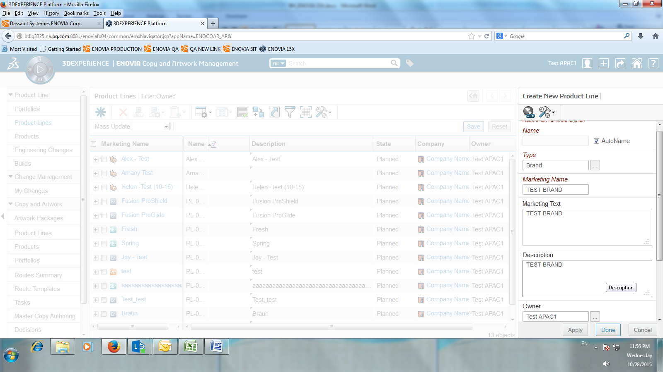

1. Then, the brand you created will display under Product Lines.

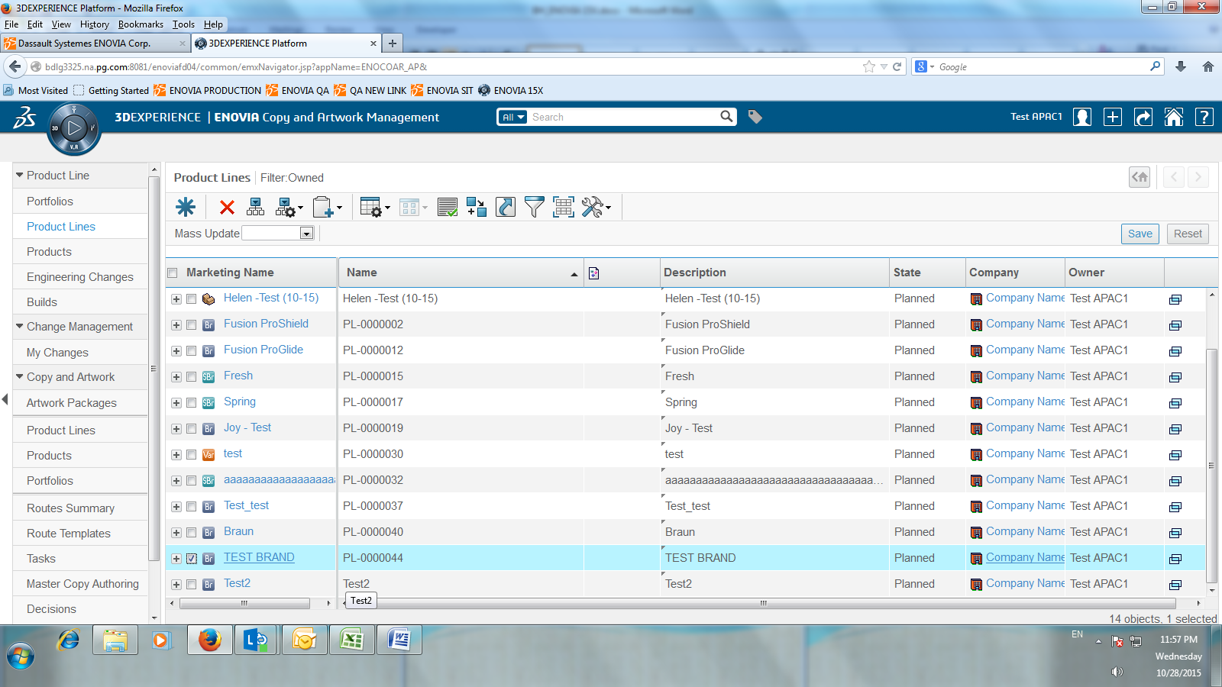

1. After creating the Brand, go to the brand level and click “**Categories**” (*To create Product Line or Product Master under Brand*)

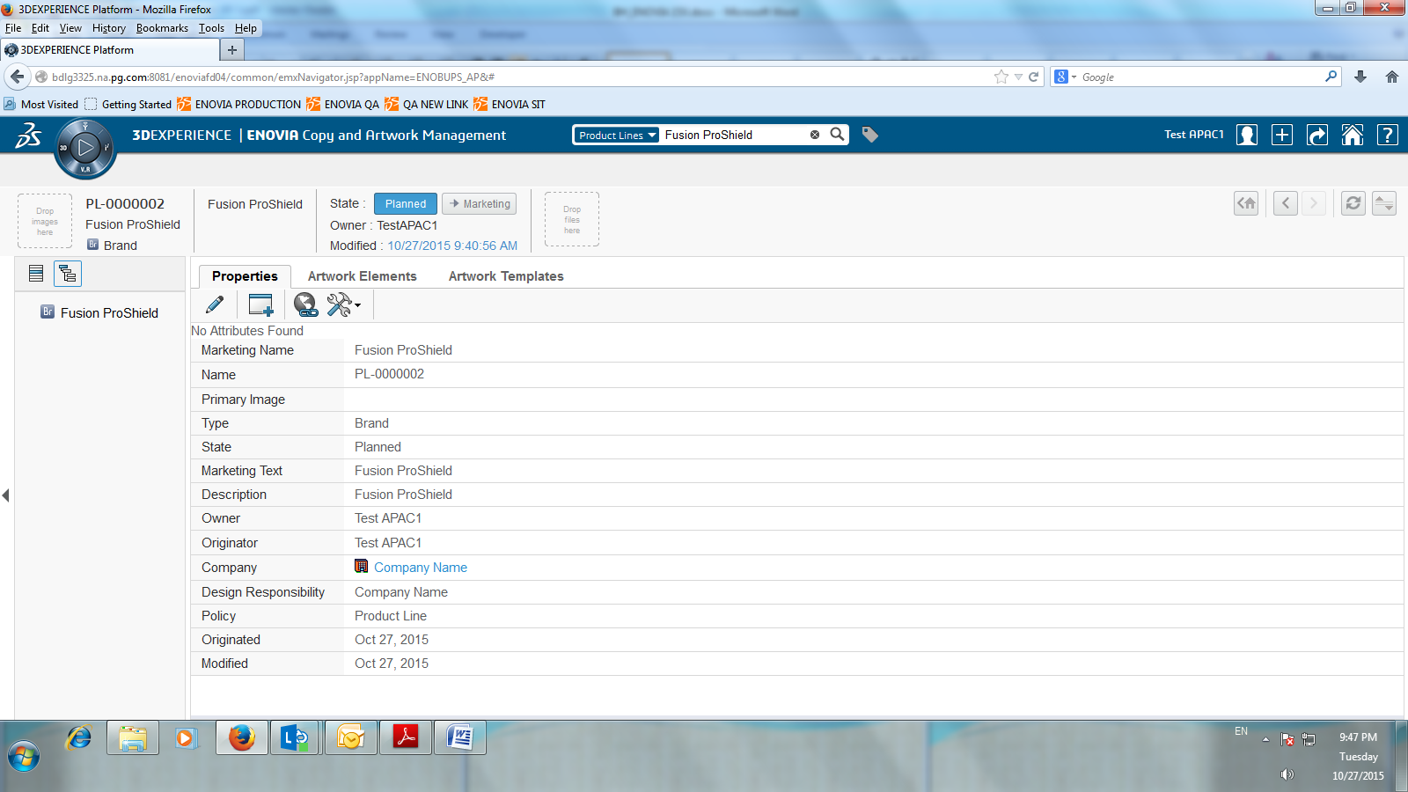

1. Click “**Product Hierarchy Work Place**” then mark the checkbox of the object/level where you are to setup the new product line or product master then click “**Actions**”

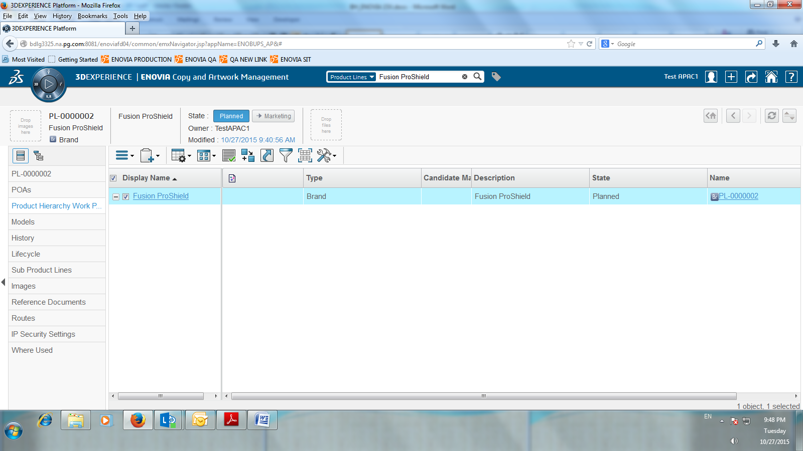

1. Select 1) “**Create Product Line…**” to create Sub brand, Commercial Variant and Segment Level,

2) “**Create Product…**” to create Product Master Level.

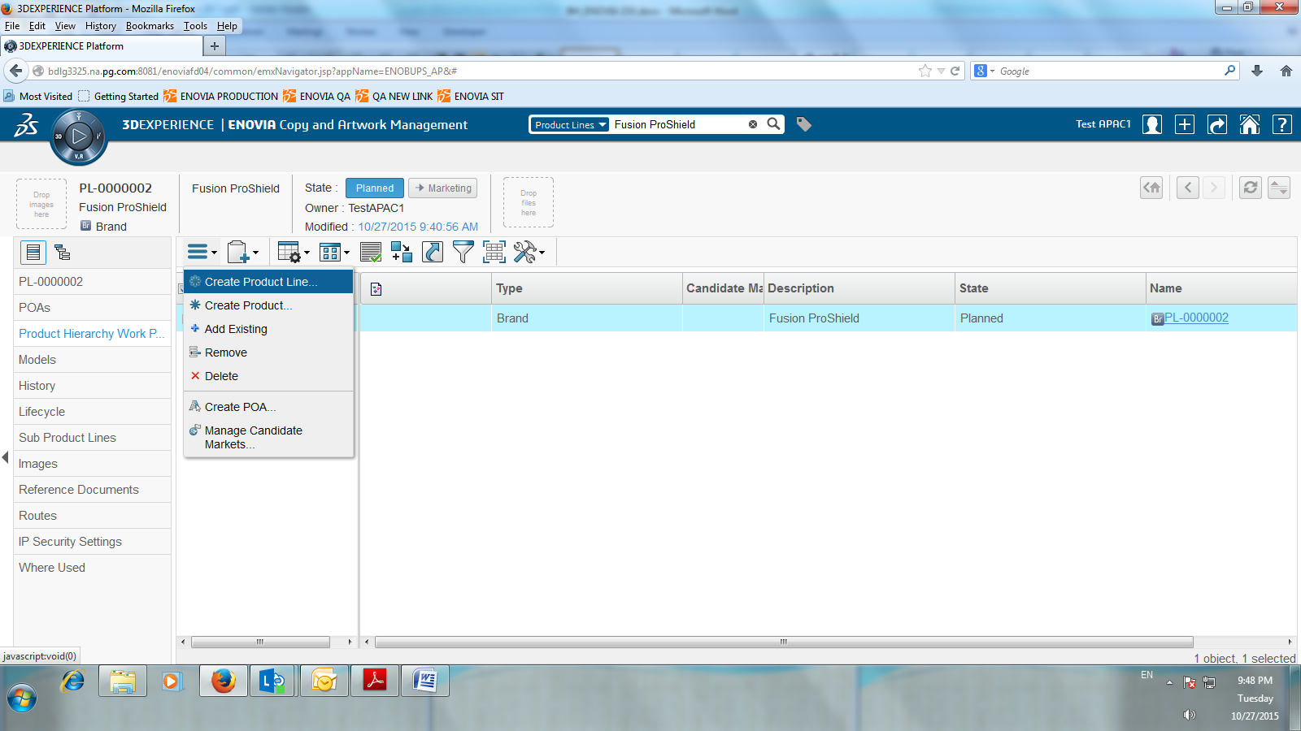

1. Enter Hierarchy Details:

**For Sub Brand, Commercial Variant and Segment Level:**

Mark the checkbox on “Auto name” for the system to automatically create the unique name of the Level you are going to create then enter the **Type**, **Marketing Name**, **Marketing Text** and **Description** then click “**Done**” button to save.

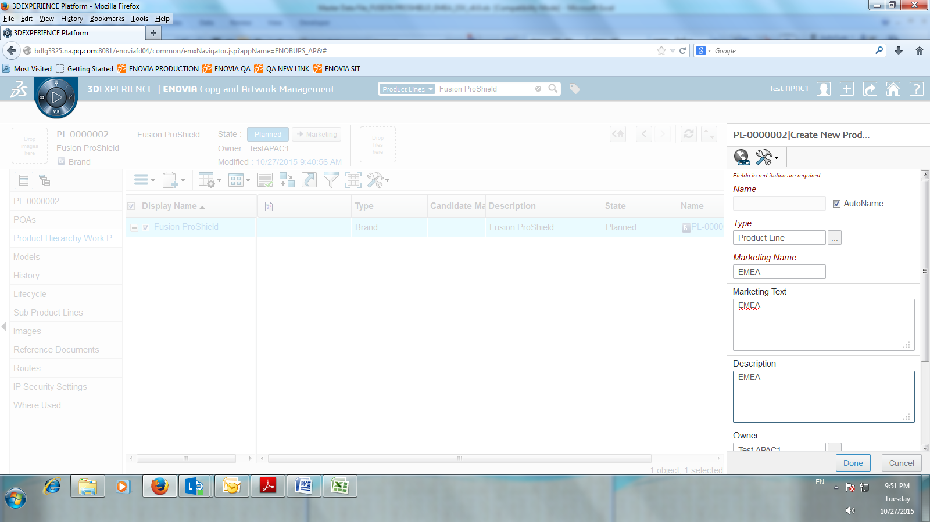

**For Product Master Level:**

Enter **Description**, **Marketing Name** and **Marketing Text** then click “**Done**” button to save.

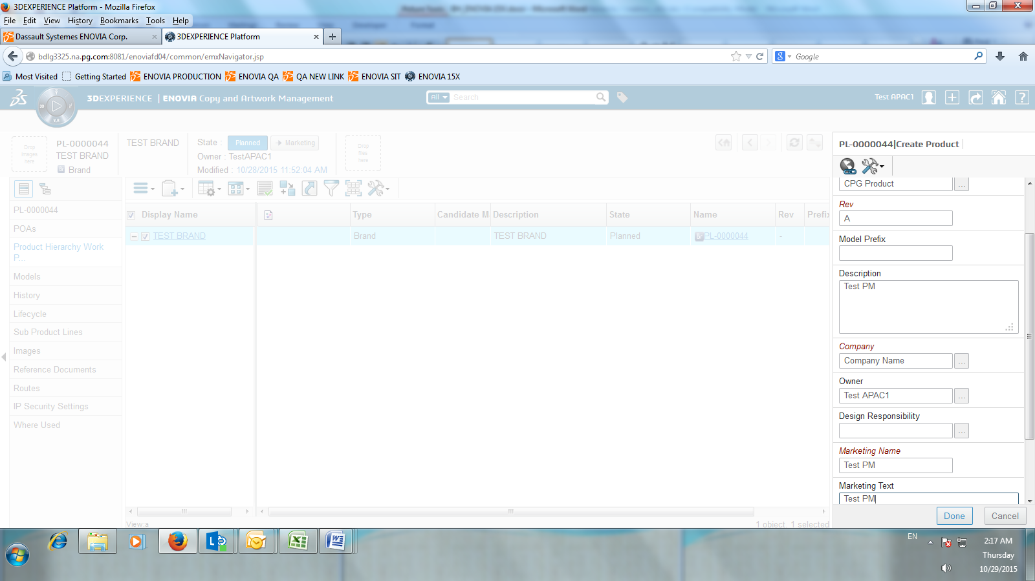

**Edit**

1. Go to the level that you're going to modify, under **Properties** tab, (for **Brand, Sub-brand, Commercial Variant, Segment and Model** level) click on the '***Pencil'***button to Edit Details.

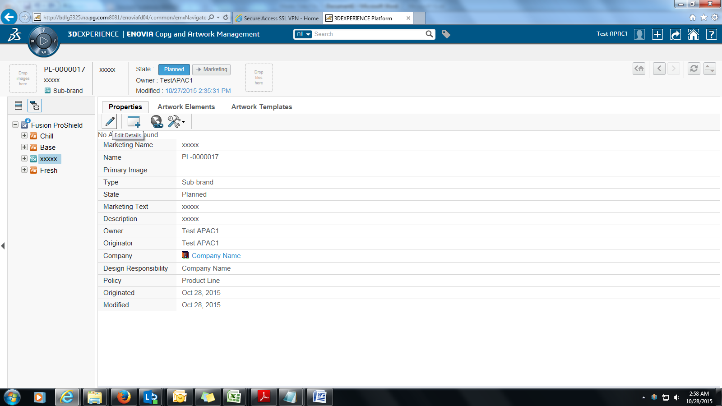

1.1 For **CPG** level, click **Actions** on the Properties tab then select **Edit Details.**

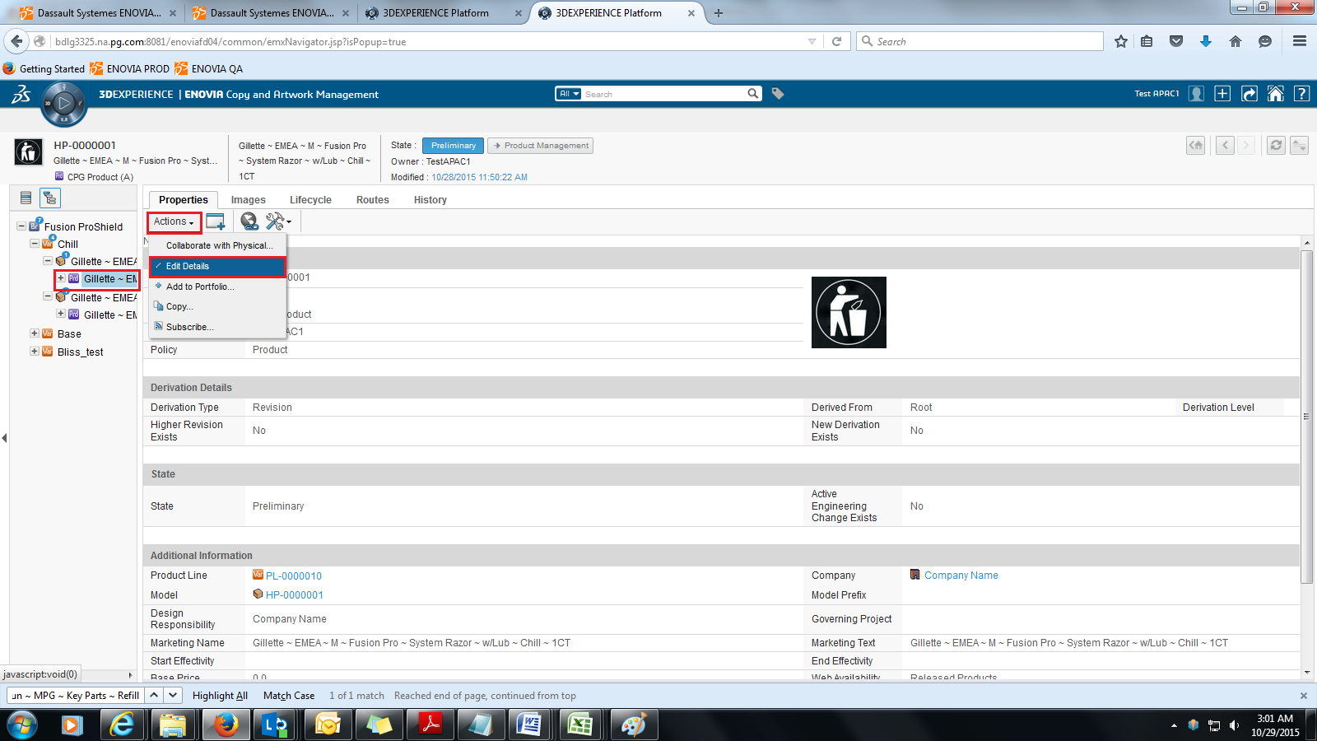

2. Under **Additional Information,** edit all the details in "Marketing Name", Marketing Text" and "Description". Then, click **DONE** to save.

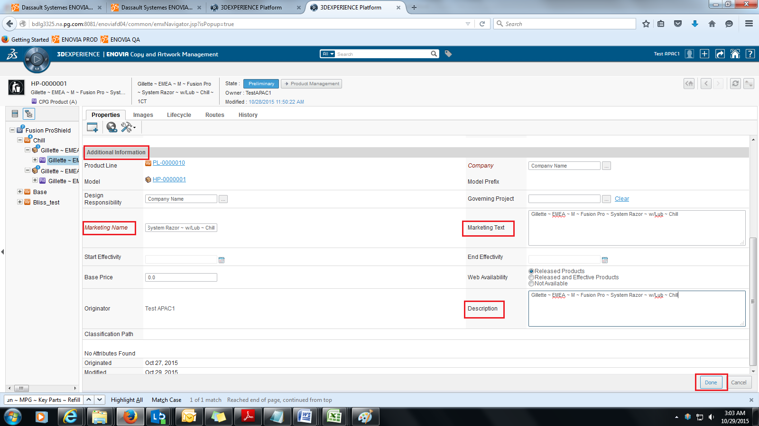

**Remove/Delete**

1. To delete/ remove a specific level in the hierarchy, go to the **Brand level**, select **Categories**  then click **Product Hierarchy Work Place.**

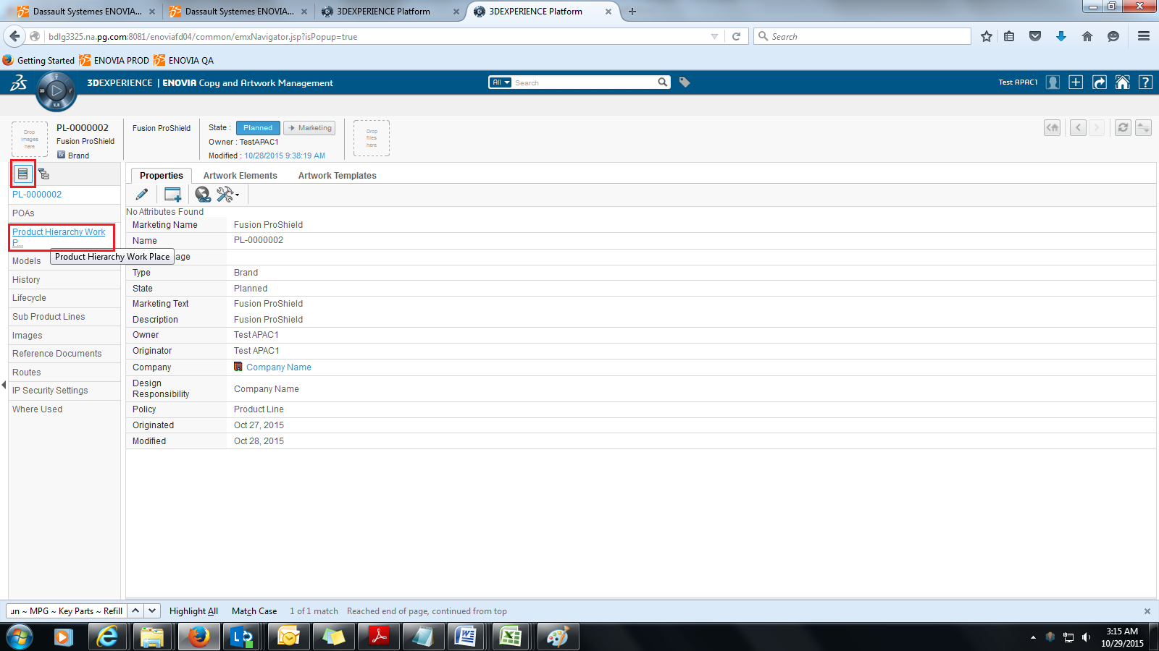

2. Tick the specific level that you're going to remove/delete. Click **Product Actions**  and select Remove/Delete. Once you click on Remove/Delete, a warning statement will appear. Click '**OK**' button to Remove/Delete.

**NOTE:** Remove Function only remove an item but it doesn't delete this item from the system.

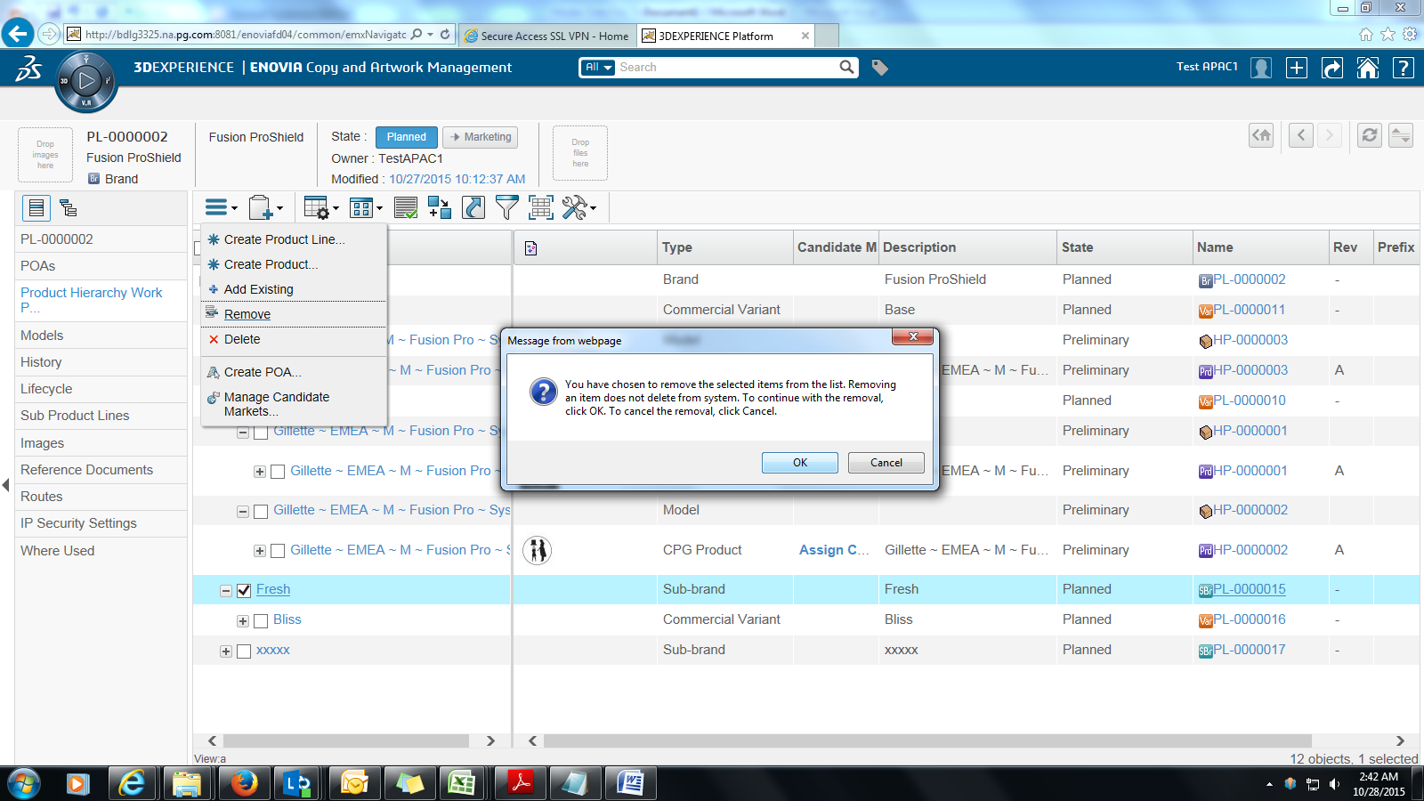

**NOTE:** Deleted items can no longer be accessed from the system.

